Proposal for

Development of the A Web-based Data Acquisition System with Capabilities of Visualizing and Analyzing the Data in Real-Time

Submitted by



Date: Saturday, November 24, 2012

Table of Contents
- Project Objective ….. ………………………………………... 3
- Our Proposal.……………..…………………………………... 3
- Application Diagram…………. ……………………………... 4
- Business Requirements ……..………………………….…….. 5
- Outline of Sections ……………………………….…….…….. 6
- Team Formation…………………………………………..….. 7
- Budget for project ………………………………….……….. 8

1.) Project Objective:
“A web-based data acquisition system with capabilities of visualizing and analyzing the data in real-time”

ICCCAD required the following:
(Quoting from the mail received from Golam Monowar Kamal on Oct 27, 2012):
“Specification:
a. Mobile based
b. Real time data collection and processing
c. Real time data visualization and export
d. Data export as database or excel format
e. Online mapping interface (optional)”

2.) Our Proposal:

We will use SMS for data acquisition and web-host the acquired data and relevant visualization. Judging by the fields of the questionnaire and their possible answers, we believe a single SMS (160 character restriction) will be adequate to capture information pertaining to a household.

System Requirements
Application Type | - | SMS and web application
SMS getway |  | Any operator BUT we prefer GP.
Port number |  | 2233
Web Server | - | Apache HTTP Server 2.2 or higher
Application Server | - | Linux
Database Server | - | My SQL
Application Tools | - | HTML,CSS,JS,PHP
The domain and host will be hosted in a secure, robust server with minimal downtime.
Database

My SQL will be used as the Relational Database Management System (RDBMS). The database will be designed with an ‘object oriented view’ in mind and special emphasis will be given on minimising data redundancy and maintaining data integrity. The database will be created from scratch. (Although there is no mention of existing data migration in the requirement specification document provided by end-user, the data may be, if required by the client, migrated into the new database.)

3.) Application Diagram

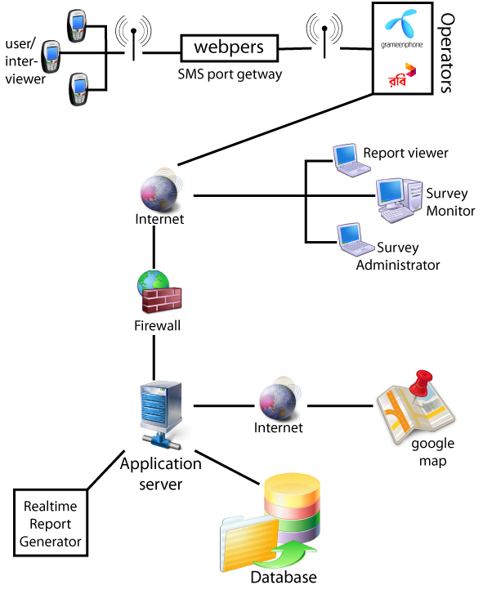

4.) Business Requirements

4.1) Problem Statement
Development of “A web-based data acquisition system with capabilities of visualizing and analyzing the data in real-time” for ICCCAD.

4.2) Business Goals
The following business goals will be achieved by the new website:
- Design data acquisition portal of ICCCAD
- Generate run time report
- Searchable interviewer information and interviewee information
- Graphs for all questions (by village)
- Graphs on aggregate data (all village)
- Raw data for all entries
- Static map with village tagging.
- Export option for all graphs data.
- Export option for raw data.
- Intuitive, user-friendly interface
- Simplicity

4.3) Project Assumptions
- The web application will be available online for everyone.
- Registered all interviewers including village allocation.
- Any user can find a specific data through this web application
- Data collection using SMS for selective question
5.) Possible Outline of Sections

- Home page
- Monitoring panel
  - Login
  - Self data and profile info
  - Monitoring matrix
  - Raw sms by user
    - Detail data
  - Search by interviewer
    - Detail data
  - Search by question
    - Details for all interviewers

- Admin panel
  - login
  - add interviewer
  - raw message table with time
  - add village info
  - assigning interviewer to village
- Run time report : graph
  - Graph by village for each question
  - Aggregated graph
  - Graph slideshow for all questions
- Run time report : data
  - Data table by village for each question
  - Aggregated data table
- Static map
  - Tag all village
  - Hover info for that village
- Export report
  - pdf
  - csv-excel
- Search option
  - By village
- About ICCCAD
- About this project
- User experience (Feedback)

6.) Team Formation

A team of six members will be assigned to this project as defined in the chart below.

Team Member Roles | No. of persons | Names
Project Supervisor | 1 | Dr. Ali Shihab Sabbir
Project manager / architect designer / database programmer | 1 | Md .Mosharraf Hossain
Web developer & Software Engineer | 1 | KS Rahman
Interface Programmer/ Graphics Designer | 1 | Raihan Bin Rafique
Graphics Designer/ markup Engineer | 1 | Md. Jasim
Software Quality Assurance Engineer | 1 | Nazmul Hasan
Total: | 6

7.) Budget Proposal for SMS Driven Web-Application Development for
data acquisition system with capabilities of visualizing and analyzing the data in real-time.

Team leader, Software Architect (Dr. Ali Sabbir) | Free Consultation
DBA & Chief web developer (Mosharraf Hossain) | 60hr X $25 | = | 1500X82 Tk | = | 123,000
1 Web developer & Software Engineer | 60hr X $12 | = | 720X82 Tk | = | 59,040
2 Front-end Developer | 2X40hrX $12 | = | 960X82 Tk | = | 78,720
1 QA Tester | 40hrX$8 | = | 320X82 Tk | = | 26,240
SMS port management |  |  |  |  | 13,000
Total Cost : |  |  |  |  | 300,000

The price includes setting up and maintenance of a web-server and a database server for two months after delivery of the application.

The price includes renting and maintaining a shared communication port through which SMS will be sent and received for two months after delivery of the application.

The price does not include any SMS charge.

In order to take full advantage of this development, the application needs to be hosted on a robust, fail-safe server. Also the data acquired through the application should be made available 24/7. Beyond the first two months, we can provide these services for a fee of 24,000Tk ($300)/month. (As mentioned above, first two months of service is free).

